Content Writing Services in Kuwait

Content:

[Content](https://www.simplilearn.com/digital-selling-types-of-high-value-content-article) [is](https://digitalmarketingtrust.com/) any information that educates, informs, entertains, motivates, inspires, convinces, or persuades a particular group of people.

Content Writer:

Content essayist is a person who is capable in laying out an image with their words. Additionally, they are proficient written communicators and possess language proficiency. The writer needs to show off their creative and witty side if the content needs to entertain people.

Then again, in the event that the substance required should teach, the substance author should have the option to do persistent examination regarding the matter. The substance essayist is a person who ensures that the association's adage, their objectives, are passed plainly on to their customer base through composed media.



Content Writing:

Content writing is the fine-crafted art and structural science of making content for digital media. The different types of content writing   on the digital front include blogs, scriptwriting for videos, e-mailers, social media posts, whitepapers, etc. All of these are important for the digital growth of a brand.

 Content Writer is a professional who writes informative and engaging articles to help brands showcase their products. They write on a range of subjects and are responsible for creating the best possible written or visual content, from blog posts to press release

Content is as important as the design and aesthetics of your website because it drives search engine results, increases traffic to your page and establishes your organization as an industry leader. And in today’s content marketplace, both quality and quantity determine your ability to leverage **content for business results**.

It includes:

, SEO writing

Copywriting

, Creating social media posts

, email campaigns

, Script writing for video content

Make content that is concise and clear by diligently researching the information. Ensure that the organization's goals are met through your words. Edit content to make it concise. Use their skills to write blogs, marketing content, scriptwriting, and other types of content.

Tips for Effective Content Writing:

Although there is no secret formula for writing high-quality content, these are several tips that can help improve the quality and quantity of your written material:

1. **Write a Head-Turning Headline.** The headline determines whether audiences will read the rest of your work. If the headline doesn’t spark interest, stir an emotion or make the reader want to learn more about the topic, you simply won’t achieve the desired results with your content. Walker Sands’ professional copywriting services take the guesswork out of generating effective headlines by using proven techniques and traffic-driving strategies.
2. **Create a Hook That Grabs Their Attention.** You have three seconds to keep readers hooked after the headline. The first sentence also plays a role in determining whether they read the rest of your content. As a result, it should capture the reader’s attention and smoothly lead them into your first point.
3. **Do Your Research.** You must have extensive knowledge on the topic you’re writing about, especially in the B2B market. Include statistics, data and metrics to establish credibility and support your claims

.

1. **Focus on a Single Purpose.** You should identify at least one key message you’d like to convey before you create your content. Keep this in mind when writing and tie your content back to the main point as much as possible.

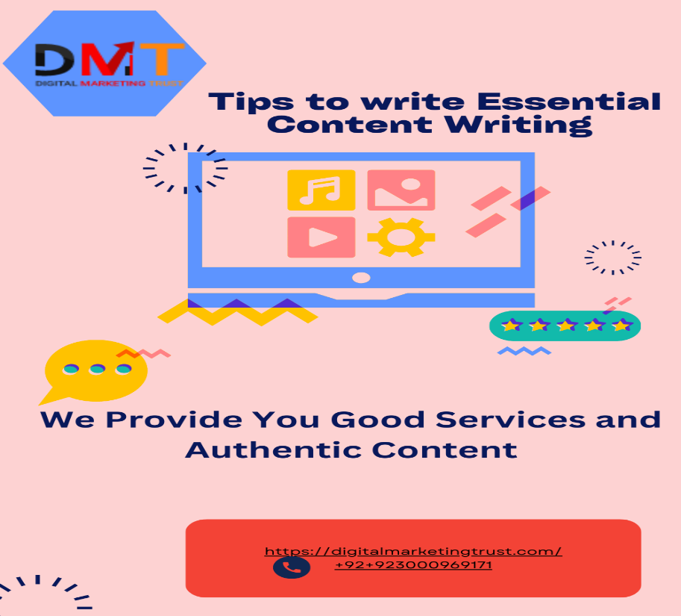

1. **Write in a Unique Voice.** The content you publish is the voice of your company and it should be unique to your company’s personality. It’s important to align the tone of your writing to your target audience, business goals and brand persona.
2. **Optimize Digital Content.**The best digital content often consists of short paragraphs, short sentences and bulleted lists. Digital content should also be optimized for search using SEO best practices and the latest SEO content strategies.
3. **Edit Your Work.** After you have created a first draft, go back and consider how you might polish the rough edges of your writing. In most cases, writing improves as it goes through a round or two of edits—even when it has been drafted by experienced content creators.

Content Writing Services:

In order for you to make an educated decision, here is a ranking of the best content writing services in Kuwait.

To appear on the first page of Google search results, you must have original, authentic content. Maybe that is the reason **"quality writing is everything**" is an expression that rings in the ears of content advertisers .Website s and blogs that produce high-quality content consistently keep readers interested. This, in turn, helps a company stay at the top of search results and market its brand more effectively.

A professional content writing service to boost your content marketing efforts. In order for you to make an educated decision, here is a ranking of the best content writing services .To appear on the first page of Google search results, you must have original, authentic content. Perhaps this is why content marketers often hear the phrase **"content is king."**. Pre users stay for all time drew in with great substance creating sites and online journals. This, in turn, helps a company stay at the top of search results and market its brand more effectively.

However, constantly producing original and up-to-date content presents a significant challenge for some businesses, which is why the trend of outsourcing content creation has gained traction.

Numerous content writing services have emerged as a result, promising to produce high-quality content for you quickly and affordably, giving you more time to invest in expanding your business

Learn about some of the best content writing services .The requirements of various businesses vary. You can get the consistency and quality that you need with professional content writing services. A content writing company with skilled writers devises strategies and constructs gripping narratives that create the ideal connection between your target audience and your brand. Additionally, it will make all of your content-related operations simpler. PPW, or a decent cost for each word, most happy composing administrations charge. However, a lot of companies that make content also offer pricing plans that link subscription plans to predetermined amounts of content . you can get in touch with them if your business needs engaging content.

**The Benefits of Outsourcing Content Writing Services:**

There are numerous advantages to working with a seasoned article writing service, some of which are obvious:

* You won't have to worry about find a writer.
* A team will be ready to go by the agency;
* You must inform them of your requirements.
* You'll be able to concentrate on growing your business without worrying about content when you hire an agency. Additionally, they have written a variety of articles previously.

Different advantages of recruiting outside essayists for your substance incorporate more proficient substance tasks, admittance to incredible material, working with an enormous gathering of journalists with shifting ranges of abilities, better motor rankings search, memorability and expanded transformation rates.

In the United States, employs thousands of content writers to provide various industry-specific website writing services. This service, which claims to be a "content marketing enthusiast," has writers who have worked in a variety of fields, so you can find someone who can write authoritative content.

You can get a professional web writing service from our web editing company. We compose web content in accordance with your article contract or your corporate marking.

With the help of our articles and other editorial formats, you can increase the number of people who know about your business, increase the number of people who visit your website, and boost sales on your online store.



The simplest status to become an influencer is self-employment. Indeed, you will only pay social security contributions if you generate income. Your web writing projects are treated individually for each one.

In order to guarantee you prompt delivery that adheres to your deadlines, our advisors and project managers make sure that all of your content orders run smoothly.

Redacteur.com is convinced that human writing guarantees unique, high-quality content. Receive 100% guaranteed human texts without duplicate content

Your texts are archived with the most recent news and studies distributed and composed by proficient scholars, adhering to your guidelines, to accomplish your goals.